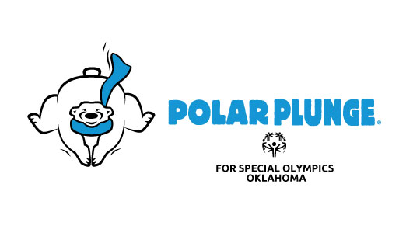
Plunge Registration Form
Name: Age: Email:________________________
Address________________________City:________ State: Zip:______
Law Enforcement Agency (if applicable):_______________Total Money Turning In:___

Waiver & Release Form
In consideration of participating in the Polar Plunge, I represent that I understand the nature of the Polar Plunge event and that I and/or my minor child am qualified, in good health, and in proper physical condition to participate in such an Activity. I acknowledge that if I and/or my minor child believe event conditions are unsafe, I and/or my minor child will immediately discontinue participation in the Activity.
I fully understand that the Polar Plunge event involves risks of serious bodily injury, including permanent disability, paralysis, and death, which may be caused by my own actions or inactions, those of others participating in the event, the conditions in which the event takes place, or the negligence of the "releases" named below; and that there may be other risks either not known to me or not readily foreseeable at this time; and I fully accept and assume all such risks and all responsibility for losses, costs, and damages I and /or my minor child incur as a result of my and/or my minor child's participation in the Activity. Diving or flipping into the pool/body of water is prohibited.
I hereby, and for my minor child, heirs, executors and administrators, waive, discharge, and covenant not to sue The Law Enforcement Torch Run of Oklahoma, Special Olympics Oklahoma, Arrowhead Resort, Campus Corner in Norman, O’Connell’s, Safari Joe’s H2O, White Water Bay, Hurricane Harbor, Eskimo Joe’s, City of Pauls Valley, Wacker Park, Donald W. Reynolds Recreation Center, City of Bartlesville, Hilton Garden Inn, City of Stillwater, Choctaw Nation- Oasis Pool, Country Leisure Manufacturing Co.,Lawton Country Club, City of Enid, Western Inn & Suites, City of Poteau, Choctaw Country Club, City of Weatherford, Kiwanis Baseball Complex, Best Western, City of Okmulgee, Dripping Springs Lake, Ugly John’s, Avana Arts District, Lee|Coats Law, PLC- Attorneys & Counselors at Law its respective administrations, directors, agents, officers, volunteers, employees, other participants, any sponsors, advertisers, and if applicable, owners and lessors of premises on which the Activity takes place (each considered one of the "RELEASEES" herein), from all liability, claims, demands, losses, or damages on my account and/or that of my minor child caused or alleged to be caused in whole or in part by the negligence of the "releases" or otherwise, including negligent rescue operations; and I further agree that if, despite this release, waiver of liability, and assumption of risk, I, or anyone on my/and or my minor child’s behalf, makes a claim against any of the "Releases," I will indemnify, save, and hold harmless each of the releases from any loss, liability, damage, or cost which any may incur as the result of such claim.

I have read this RELEASE AND WAIVER OF LIABILITY, ASSUMPTION OF RISK, AND INDEMNITY AGREEMENT, AND PARENTAL CONSENT AGREEMENT, understand that I have given up substantial rights by signing it and have signed it freely and without any inducement or assurance of any nature and intend it be a complete and unconditional release of all liability to the greatest extend allowed by law and agree that if any portion of this agreement is held to be invalid the balance, notwithstanding, shall continue in full force and effect.

__________________________
Date
_________________________________________ ___________________________________________
Printed name of participant Signature of Participant or Legal Guardian (if participant is under age 18)

