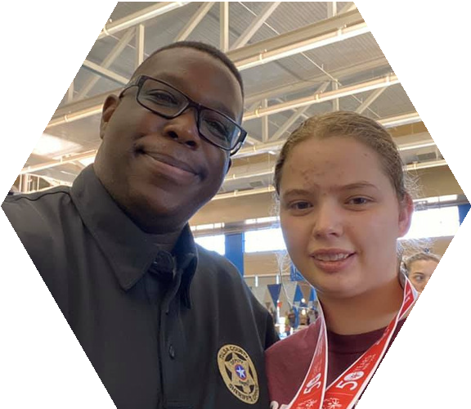

HELP US SUPPORT SPECIAL OLYMPICS

OKLAHOMA!
Tip-A-Cop Fundraiser

Enjoy dinner at while local law enforcement officers help serve you food! 100% of the tips you donate to the officers will directly benefit 12,100 Special Olympics Oklahoma athletes.

For more information about Law Enforcement Torch Run for Special Olympics Oklahoma, please visit
www.sook.org

