Oklahoma Special Olympic
Tennis Rules

- GOVERNING RULES
The Official Special Olympics Sports Rules for Tennis shall govern all Special Olympics competitions. As an international sports program, Special Olympics has created these rules based upon International Tennis Federation (ITF) Rules for tennis found at http://www.itftennis.com/. ITF or National Governing Body (NGB) rules shall be employed except when they are in conflict with the Official Special Olympics Sports Rules for Tennis or Article I. In such cases, the Official Special Olympics Sports Rules for Tennis shall apply.
- OFFICIAL EVENTS
The range of events is intended to offer competition opportunities for athletes of all abilities. Programs may determine the events offered and, if required, guidelines for the management of those events. Coaches are responsible for providing training and event selection appropriate to each athlete’s skill and interest. The following is a list of official events available in Special Olympics:
2.1 Individual Skills Competition – 36-foot court; Red ball
2.2 Singles – 36-foot court; Red ball
2.3 Coed Doubles– 60-foot court; Orange ball
2.4 Unified Sports Doubles– 60-foot court; Orange ball
3. RULES OF COMPETITION
3.1 Divisioning
3.1.1 Competitors can register for any two events listed in 2.1-2.4
3.2 Match Play
3.2.1 Two short sets using no-ad scoring with a 7-point match tie break to decide the match. In a short set, the first player/team who reaches 4 games wins that set. If set score is 3-all, the next game wins the set. When the score in a match is one set all, one 7-point tiebreak game shall be played to decide the match.
3.2.2
3.2.2 The No-ad scoring system will be used for all match play. The first player to win four points wins the game, with the seventh point of a game becoming a game point for each player.
3.3 No-Ad Scoring
3.3.1 Singles Matches
3.3.1.1 The receiver has the choice of advantage court or deuce court, the service on the seventh point, is to be delivered to the nominated court.
3.3.2 Doubles Matches
3.3.2.1 The receiving pair has the choice of advantage court or deuce court, the service on the seventh point, is to be delivered to player playing in the nominated court.
3.3.3 Unified Doubles Matches
3.3.3.1 The service on the seventh point is to be delivered athlete to athlete or partner to partner.
3.3.4 Score Calling
3.3.4.1 The score calling may be either in the conventional terms or simple numbers, i.e., “zero, one, two, three, game.”
3.4 Coaching
3.4.1 One designated Special Olympics coach may sit on court, (off the playing surface, in a chair located at the net post next to the umpire’s chair) and may coach a player when the players change ends at the end of every odd game and during the three-minute rest period prior to the deciding tie-break, and not during a tie-break game. Changes of ends must be completed within 90 seconds.
3.4.2 Scoring Assistance. Special Olympic coaches may assist with scoring throughout the duration of the match. However, no coaching outside the parameters of 3.4.1.
3.5 Draw Formats
3.5.1 All draws for singles, coed doubles and unified doubles shall be in non-elimination format. Approved draws are round robin brackets are compass draws.
3.5.2 Round Robin Place Tie-Breakers. Determining order of finish. The player who wins the most matches is the winner. If two players are tied, then the winner of their head-to-head match is the winner. If three or more players are tied, the Referee shall use the following steps in the order listed to break all ties. The Referee shall break as many ties as possible using a given step before using the next step. These steps are:
1. The head-to-head win-loss record in matches involving just the tied players;
The player with the highest percentage of sets won of all sets completed;
2. The head-to-head win-loss record in matches involving the players who remain tied;
The player with the highest percentage of games won of all games completed;
3. The head-to-head win-loss record in matches involving the players who remain tied; The player with the highest percentage of sets won of sets completed among players in the group under consideration; The head-to-head win-loss record in matches involving the players who remain tied;
4. The player with the highest percentage of games won of games completed among the players under consideration; and
The head-to-head win-loss record in matches involving the players who remain tied.
5. If the referee has applied all the steps and a tie still cannot be broken, the referee shall use a random drawing among the remaining tied players to determine their order of finish.
3.6 Unified Sports Doubles
3.6.1 Each Unified Sports doubles team shall consist of one player with an intellectual disability and one player without an intellectual disability, who have similar skills as defined by their New ITN Rating and ITN total score.
3.6.2 Each team shall determine their own order of service and selection of courts (ad or deuce).
3.6.3 If teammates are individually rated at different levels the team must compete at the level of the highest rated teammates.
3.7 Individual Skills Competition
3.7.1 Level 1 ball is the red ball within a 36’ court
3.7.2 Forehand Volley
3.7.2.1 The athlete stands approximately four feet from the net with the feeder on the other side of the net, positioned halfway between the service line and the net. Each athlete is given five attempts to hit a ball safely over the net. The feeder underhand tosses each ball to the athlete’s forehand side.
3.7.2.2 The athlete scores 5 points for hitting into the service box into either service box.
3.7.3 Backhand Volley
3.7.3.1 Same as forehand volley except feeder sends the balls to athlete’s backhand side.
3.7.3.2 Each athlete is given five attempts
3.7.4 Forehand Groundstroke
3.7.4.1 The athlete stands on the baseline of a 36-foot court. The feeder is on the other side of the net, positioned half way between the service line and the net, underhand tosses the ball so it bounces once before reaching the athlete’s forehand side. Each athlete is given five attempts.
3.7.4.2 The athlete scores five points for hitting within the sidelines and baseliner of a 36-foot court.
3.7.5 Backhand Groundstroke
3.7.5.1 Same as forehand groundstroke except the feeder sends the ball to the athlete’s backhand side. Each athlete is given five attempts.
3.7.6 Serve – Deuce Court
3.7.6.1 A legal serve is defined as an overhead motion or an underhand motion with no bounce
3.7.6.2 Each athlete is given five attempts to hit a legal serve from the right court to the deuce service box. A ball landing in the correct service box will count 10 points. A zero (0) score is recorded if the athlete commits a foot fault or fails to get the ball in the service box. A foot fault occurs when the athlete steps on or over the service line.
3.7.7 Serve – Advantage Court
3.7.7.1 Same as serve to deuce court but from the left court to the advantage service box.
3.7.8 Alternating Groundstrokes with Movement
3.7.8.1 The athlete begins on the baseline of a 36-foot court. The feeder is on the other side of the net positioned halfway between the service line and the net. It alternates underhand tosses to the athlete’s forehand and backhand sides. Each toss should land at a point which is both halfway between the service line and the net and halfway between the center service line and singles sideline. The athlete must be allowed to return to the center mark before feeding the next ball. Each athlete is given ten attempts.
3.7.8.2 The athlete scores five points for hitting within the sidelines and baseline of a 36-foot court.
3.7.9 Final Score
3.7.9.1 A player’s final score is determined by adding together the scores achieved in each of the seven events which comprise the Individual Skills Competition.
4. LEVELS
The following is a guide to levels designed to provide competition opportunities to athletes of all abilities.
4.1

Level 1 | Individual Skills | 36’ Court – Red Ball
Level 2 | Singles | 36’ Court – Red Ball
Level 3 | Coed & Unified Doubles | 60’ Court – Orange Ball
4.2 Level Court Diagram
4.2.1 Red Ball Court 36‘ x 18’
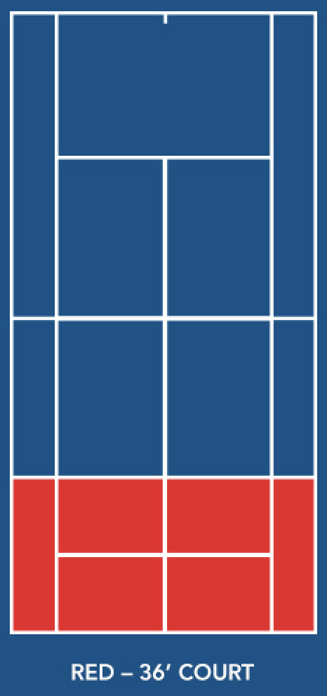
4.2.2 Orange Ball Court 60’ x 27’
